**Human Resource Tool**

***Team members:***

Luis Ernesto Zambrano - 1796133

Alexander Ponomarev - 1796188

**Description:**

The project we want to focus on would be as you have probably noticed Human Resource simple ERP. The purpose is to make the business process run smoother and in more organized manner for every small company the application might be used by. There would be functionality related to CRUD operations of creating, editing and deleting the employees entries. We are planning as well to add check in feature to track the attendance and lateness of the employees. All the databasestructure is planned to be placed on Azure.

*The technologies we are going to be using are:*

**WPF** for the client software

**WCF** for webservice server

**Screenshots**

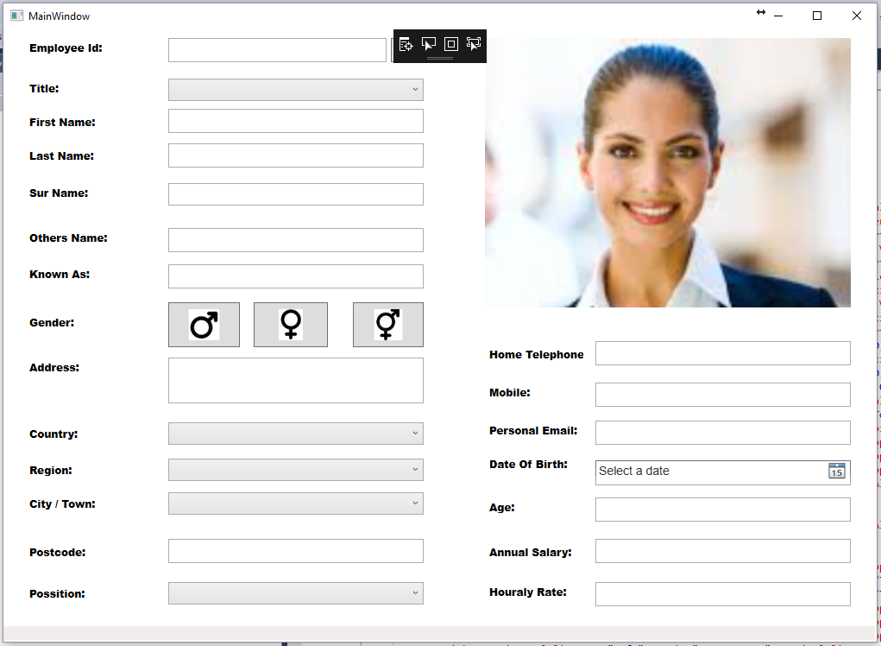

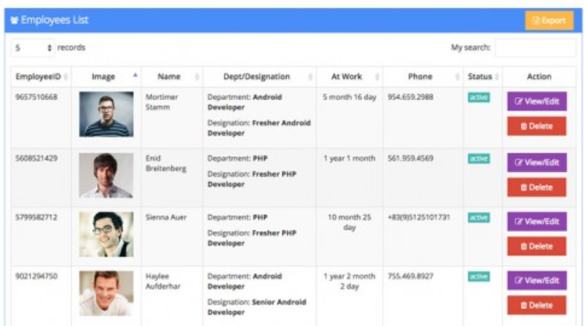

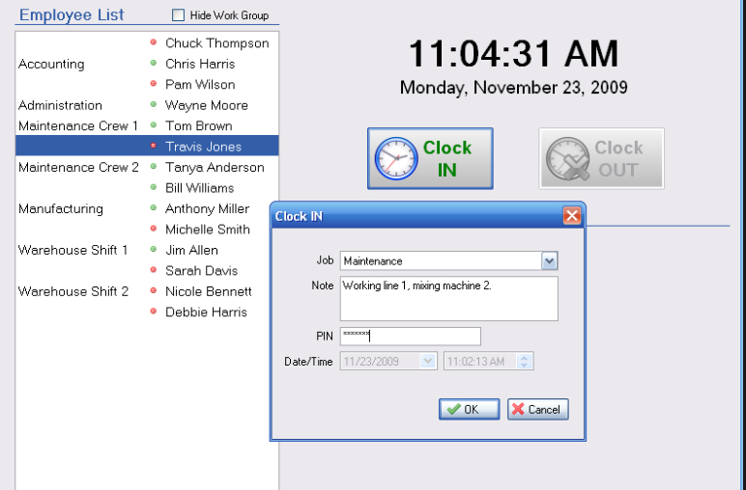

**Database**

